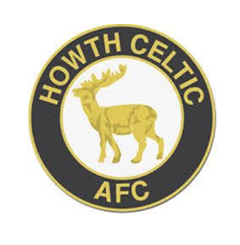
Respect all, Fear none

Consent Form

As a Parent/Carer of an U18 PLAYERS please read and complete this form. All information will be treated with sensitivity, respect and will only be shared with those who need to know.

CONSENT – SHARING OF INFORMATION U18 PLAYER
I consent
I do not consent*
to the Howth Celtic AFC sharing information about me with its affiliated organisations which it governs as deemed appropriate for my wellbeing.

CONSENT – MEDICAL TREATMENT U18 PLAYER
I consent
I do not consent*

to receiving medical treatment, including anaesthetic, which the medical professionals present consider necessary.

CONSENT – TRANSPORTATION OF CHILDREN
I consent
I do not consent*
Howth Celtic AFC will ask any person using a private vehicle to declare that they are properly licensed and insured and, in the case of a person who cannot so declare, will not permit that individual to transport U18 players.

U18 PLAYER
I consent
I do not consent*
to allow my child be transported by persons representing Howth Celtic AFC for the purposes of taking part in football.

CONSENT - PHOTOGRAPHS AND PUBLICATIONS (INCLUDING WEBSITE) Young players may be photographed or filmed when participating in football and this may be published.
I consent
I do not consent*
to allow my child be involved in photographing / filming and for information to be used for the purposes of
- Video footage for performance development
- Media coverage of an event or achievement
- Promotional purposes e.g. website or publication

CONSENT – CONTACT INFORMATION
From time-to-time Howth Celtic may contact you via email, text or social networking site. With information related to the club and the events your child may be taking part in.
I consent
I do not consent*

Should Howth Celtic AFC change any of the information contained in this form change, the club will inform you. I am aware that I can revoke any of the above consent at any time.

